**University of Victoria**

**Faculty of Engineering**

**Spring 2020 Work Term Report**

**Prototype Designs for an Autonomous Underwater Sensor-Cleaning Robot**

**Stark Industries**

**New York, United States of America**

**Alec Godfrey (Mechanical Engineering), alexandergodfrey@uvic.ca**

**Owen Crewe (Software Engineering), ocrewe@uvic.ca**

**Blaine Tubungbanua (Computer Engineering), btubungbanua@uvic.ca**

**Pablo Villegas (Mechanical Engineering), pablovillegas@uvic.ca**

**Noyan Ozyigit (Electrical Engineering), noyan@uvic.ca**

**Work Term 1**

**April 1, 2020**

**In partial fulfillment of the requirements of the**

**B.Eng. and B.S.Eng. Degrees**

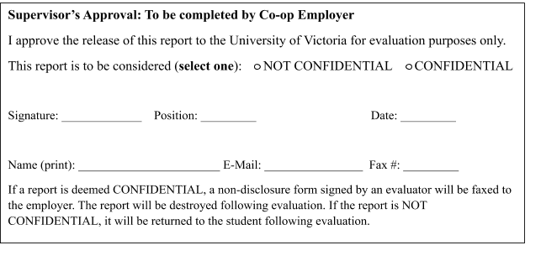

Brock Bath & Beyond

1978 Main St, Victoria, British

Columbia V84 5Z3

April 3rd, 2020

Mr. Lawrence Pitt, Coop Coordinator

Faculty of Engineering

University of Victoria P.O. Box 1700

Victoria, B.C. V8W 2Y2

Dear Mr. Pitt,

Please accept this co-op work term report “Prototype Designs for an Autonomous Underwater Sensor-Cleaning Robot”.

This report is the result of work completed at Stark Industries in New York. During our first

work term as University of Victoria students, we were individually assigned to five different teams to work on autonomous robots designed to locate and target an object, place a simulated cleaning device on it and finally signal when the task is completed. As an electrical engineer, I, Noyan, worked on the wiring and the breadboards. Owen and Blaine both worked on programming the systems of the robot as software and computer engineers respectively. Pablo and Alec built the movement mechanism as mechanical engineers. The goal of this report is to decide which one of those designs will be most efficient and reliable to accomplish the task.

Throughout the work term, we had the opportunity to work with Stark Industries, which was a great experience for all of us. During our co-op term, each of us has gained extensive knowledge of movement mechanisms, sensor systems and C programming. We are confident that the skills we obtained will assist us all in our future work terms and careers.

We would like to thank Happy the security guard for not snitching on us when we passed our curfew, our Supervisor, Mrs. Potts, and Mr.Stark for their interest and support. You can contact us anytime at bathsquad@uvic.ca.

Sincerely,

Brock Bath & Beyond

Contents

List of Figures and Tables i

Summary ii

1.0 Introduction 1

1.1 Problem Background 1

1.2 Problem Statement 1

2.0 Discussion 2

2.1 Robot Pinchy (Alec Godfrey) 2

2.2 Marvin (Owen Crewe) 3

2.3 Robot Ocean (Noyan Ozyegit) 5

2.4 Geraldine the Robot (Pablo Villegas) 6

2.5 Robowinch (Blaine Tubungbanua) 8

3.0 Conclusion 9

3.1 Recommendations 9

3.1.1 Weighted Objectives Chart 10

3.2 References 10

# List of Figures and Tables

**Figure 1:** Robot Pinchy, rear-overhead view…………………………………………………………………………….. 2

**Figure 2**: Robot Pinchy's front-facing arm mechanism……………………………………………………………… 3

**Figure 3**: Marvin, isometric view………………………………………………………………………………………………. 3

**Figure 4**: Marvin's wheelbase…………………………………………………………………………………………………… 4

**Figure 5**: Robot Ocean, side view……………………………………………………………………………………………… 5

**Figure 6**: Geraldine, isometric view………………………………………………………………………………………….. 6

**Figure 7**: Geraldine, right side view………………………………………………………………………………………….. 7

**Figure 8**: Robowinch, front-right isometric view………………………………………………………………………. 8

**Table 1:** Weighted Objective Chart…………………………………………………………………………………………. 10

**Table 2:** Weighted Objective Chart Scoring Sheet…………………………………………………………………. A-1

# Summary

Stark Industries, an industrial tech company that has made substantial developments in

autonomous systems research, has been contracted by Ocean Networks Canada to provide a

means to clean underwater observatories. As co-op interns, we worked on five different robotic

solutions addressing the problem in unique ways. Robot Pinchy, driven by four wheels uses

pincer arms to carry the payload, allowing for a versatile payload capacity. Marvin, driven by

two wheels and a freewheel, uses a pin-release system to deliver the payload. Robot Ocean,

driven by 2 motors on 4 wheels, uses a crane mechanism to deliver the payload, which is held in

a 3D-printed box, giving Robot Ocean an extremely secure grip on the payload. Geraldine,

driven by two motorized wheels and a freewheel, delivers its payload by pushing it from a track

over the robot onto the target, but its IR detection system is inconsistent. Robowinch, driven by

four motorized wheels, uses a winch system to deliver its payload, allowing for extremely gentle

package placement. Each design uses a similar target-detection circuit, with different

locomotion, and payload delivery systems. All 5 robots were effective. Robot Pinchy proved to

most effectively address the problem proposed by Ocean Networks Canada. By using a decision

matrix, we determined that it would be the most dynamic option, for its precise targeting system,

and advanced collision-avoidance system.

# 1.0 Introduction

Dear Ahmed Salman,

Our names are Alec Godfrey, Blaine Tubungbanua, Pablo Villegas, Owen Crewe, and Noyan Ozyegit, formally known as Brock Bath & Beyond. We are writing to report on our first co-op work term experience with Stark Industries at Stark Tower in New York City, for Oceans Network Canada.

## 1.1 Problem Background

Stark Industries was founded during the Second World War to help defend America during times of crisis. The company flourished in the weapons industry for decades but has recently transitioned to a focus on technological innovation. Stark’s modern aerial vehicle production and autonomous systems research greatly benefit society. This work extends to numerous international robotics and applied science organizations, such as Ocean Networks Canada (ONC). ONC’s operations with ocean floor observatories and seismology are critical to the science community worldwide. However, this important data collection is hindered by blockage on ONC’s sensors [1], and the remote nature of this problem negates the possibility of divers or tethered machines being employed.

## 1.2 Problem Statement

ONC lacks the means to effectively maintain their underwater observatories. The goal is a system capable of cleaning the sensors on the observatories. The dry-lab prototype solution should detect a target, approach it, and place a device on it while minimizing its effects on the environment. This solution must cost less than $10,000 to build, be CSA certified, be autonomous, and be available by March 31st, 2020.

# 2.0 Discussion

This section describes the five prototype robots we designed and built using VEX [2] components during our internship.

## 2.1 Robot Pinchy (Alec Godfrey)

Robot Pinchy begins by slowly rotating in place to find its target. When it detects the target, it stops rotating. Robot Pinchy then drives directly towards the target, until it determines that it has reached the optimal position for object placement. Once positioned in front of the target, the robot begins the object placement process. It then reverses from the target, rotates away, and drives until the edge of the arena is reached. Robot Pinchy is shown in **Figure 1.**

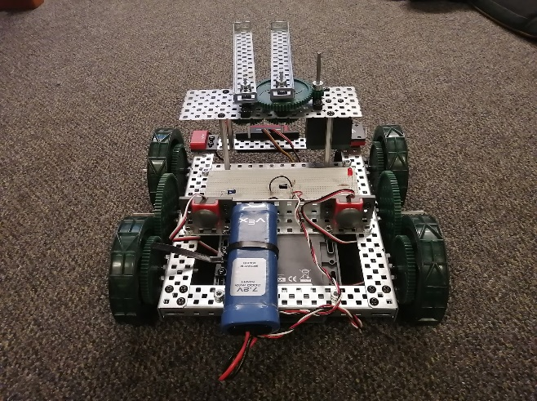

Figure 1: Robot Pinchy, rear-overhead view

Robot Pinchy detects the infrared target using two IR sensor LEDs. These face forward as part of a circuit mounted near the front of the robot, and provide a value for the level of infrared light they detect. The robot rotates indefinitely while searching for an infrared signal. When the two diodes read similar values above a threshold, the robot determines that it has detected the target and stops its rotation.

To effectively approach the target, Robot Pinchy uses an ultrasonic sensor in tandem with the infrared detection circuit to accurately gauge its distance from the target. While driving towards it, the robot constantly makes measurements to ensure a direct path. Once this distance reaches 10cm, Robot Pinchy stops.

Robot Pinchy’s dropping mechanism consists of two rotating arms on the front which support the object (see **Figure 2**). When in place, the robot can rotate these arms, causing the ends to separate and the object to fall onto the target.

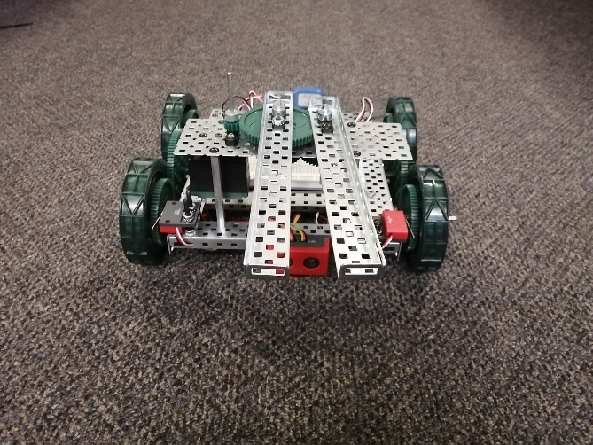

Figure 2: Robot Pinchy's front-facing arm mechanism

Robot Pinchy costs less than $10,000, every component meets CSA standards. Robot Pinchy is autonomous and will be complete by March 31st, 2020.

## 2.2 Marvin (Owen Crewe)

Marvin begins by rotating to face the target. It then drives towards the target, positioning itself. Once there, it deposits a box on the target, reverses, turns 90°, and positions itself near a wall. Marvin is pictured below in **Figure 3.**

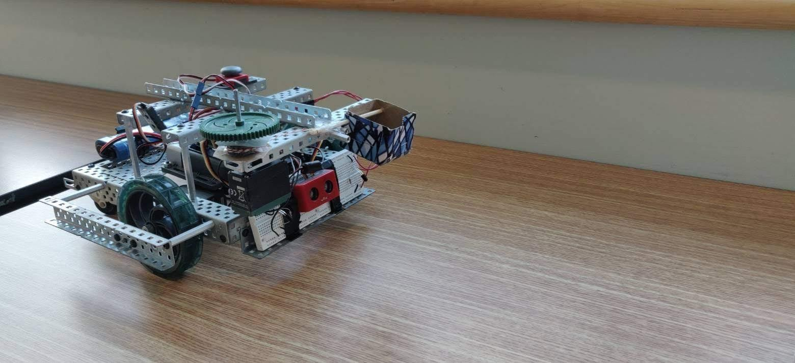

Figure 3: Marvin, isometric view

The prototype’s first process is orienting itself to face the infrared target. When activated, Marvin rotates counterclockwise while reading the average deviation in the IR sensor’s readings. The deviation reflects the 10 Hz IR emitter LEDs. Once a point of maximum IR deviation reading is reached, above the dynamic threshold calculated from average deviation reading, the orientation is fine tuned. The individual readings from both the left and right IR sensors are compared to precisely orient the robot.

When Marvin is oriented it begins to drive forwards. The prototype tends to drift, so the IR sensors are continually read, and used to modify motor voltage. Distance is read by the ultrasonic sensor. As the robot nears the target, motor power is decreased to handle inertia.

Once positioned Marvin activates the release mechanism. The pin is pulled from the delivered box, and the box is dropped approximately 1 cm onto the target. The robot then reverses, turns 90 degrees counterclockwise and reads the ultrasonic sensor to position itself 10-15 cm from the wall.

The prototype occasionally collides with walls in some starting positions. Due to the radius between the back and the center of rotation, see **Figure 4**, the robot may collide with the wall. In the final positioning procedure, if Marvin's direction of motion is at less than 35° to the wall the front-right corner will impact the wall.

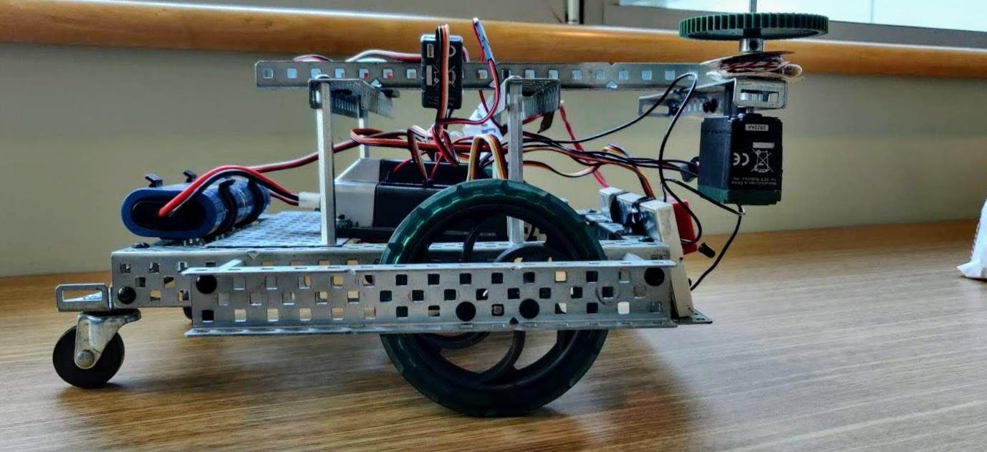

Figure 4: Marvin's wheelbase

Marvin costs less than $10,000, every component meets CSA standards. Marvin is autonomous, and will be complete by March 31st, 2020.

## 2.3 Robot Ocean (Noyan Ozyegit)

Robot Ocean starts with a 360º turn. When it has located the target, it drives towards it. When it

has reached the target, the crane lowers, placing the payload on the target. The crane retracts, and

Robot Ocean turns away, exiting the arena, lighting a green LED to signal completion.

While the prototype approaches the target, the IR sensors regularly read values to detect the

approximate distance between the robot and the target. It proceeds towards the target until the

ultrasonic sensor verifies the predicted distance is covered. Once the optimal length is confirmed

by the IR sensors, a red LED lamp flashes to indicate that the robot reached its exact position. The drive mechanism then stops and the crane begins working.

The Crane mechanism is used for “pick and place” purposes and has a scale system. It

includes a metal tube that has a rope passing through which is operated by a motor and acts as an

electric hoist. At the very end of the rope, an eye hook is attached to a 3D printed box which

holds the object. As the crane system starts working, the motor turns counterclockwise to release

the rope until the object is placed on the target which is determined by a load cell. After the

placement of the object, the robot moves backwards slightly, and the hoist motor turns clockwise

to remove the hook from the box without grabbing it again. An array of bumper switches and the

ultrasonic sensor allows Robot Ocean to avoid collisions. The side view of Robot Ocean can be

seen in Figure 5.

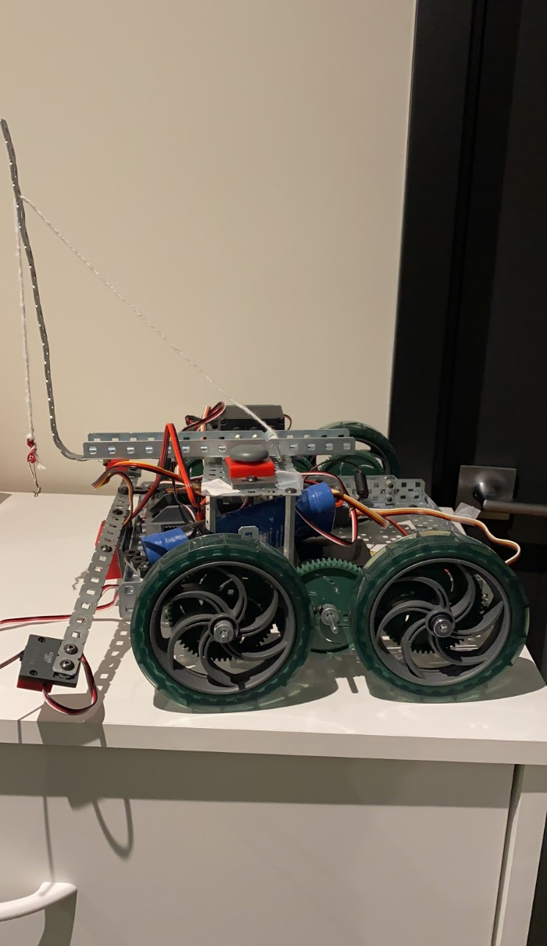

Figure 5: Robot Ocean, side view

Robot Three costs less than $10,000, every component meets CSA standards. Robot Three is autonomous, and will be complete by March 31st, 2020.

## 2.4 Geraldine the Robot (Pablo Villegas)

Geraldine commences it’s process by executing a full 360 degree turn and orients itself towards

the target. Once oriented, it drives up to the target pushes the payload onto the target. After

delivery, Geraldine turns around and drives away while emitting a red LED confirmation light.

Searching for the target, Geraldine records the position where the IR signal reads the

strongest. Following that, the Robot proceeds to turn back in the other direction until it hits that

same reading and stops. Geraldine is shown in **Figure 6**.

Once correctly oriented, the Geraldine drives forward at a constant speed. To avoid

disorientation, two encoder motors are programmed to match speed, keeping the wheels in sync.

Simultaneously, an ultrasonic sensor is used to keep track of the distance between the target and

the robot. Once the distance reaches a certain threshold, the robot indicates that the destination

has been reached using a red LED and the motors shut off.

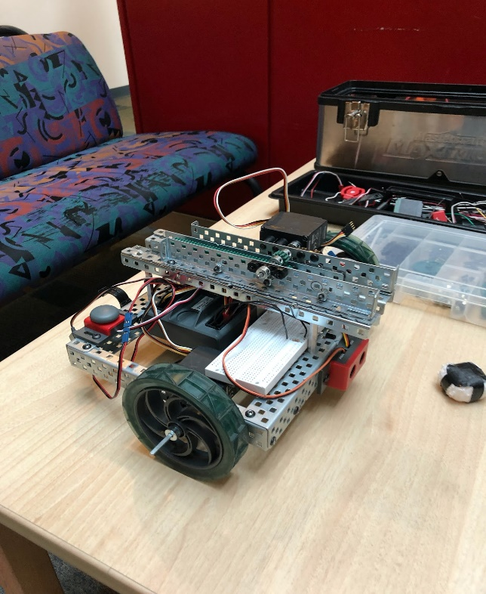

Figure 6: Geraldine, isometric view

With the robot positioned correctly, the placement mechanism activates. The arm uses an

encoder motor to push the object onto the target and retracts after completion (shown in **Figure 7.**) Another red LED notifies success and the robot reverses, turns 180° and drives again using the ultrasonic sensor to park itself a close distance to the corresponding wall, avoiding collision.

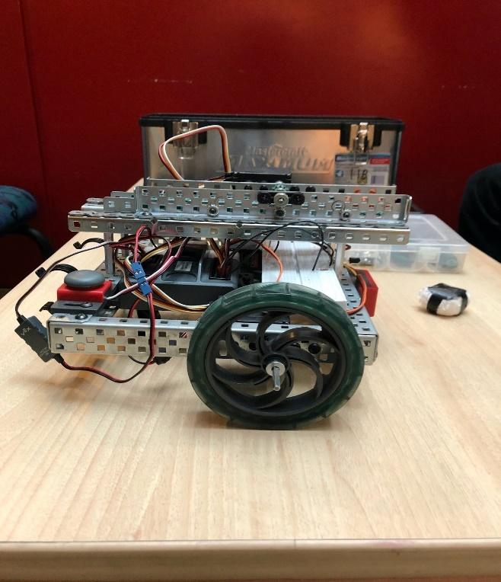

Figure 7: Geraldine, right side view

Geraldine costs less than $10,000, every component meets CSA standards. Geraldine is autonomous, and will be complete by March 31st, 2020.

## 2.5 Robowinch (Blaine Tubungbanua)

The Robowinch begins its search pattern with a 360° rotation. When the target is located,

Robowinch drives towards the target. Once it has reached the target, a winch starts unspooling a

tether that is hooked to the payload: a small bucket. Once the payload is placed, the hook

retracts. Robowinch then backs away, exiting the arena, lighting a green LED to signal

completion. Robowinch is shown in **Figure 8**.

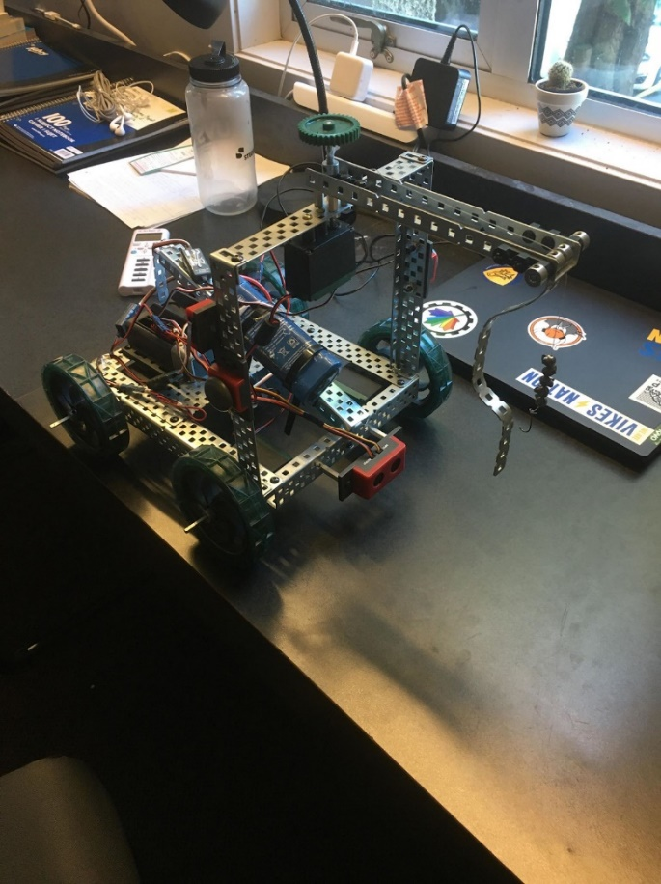

Figure 8: Robowinch, front-right isometric view

The Robowinch detects the target using 3 infra-red sensors mounted on the front. Its

search pattern involves an initial 360° rotation for the target. If the target is detected, Robowinch

begins its approach. If the target is not detected, and the ultrasonic sensor detects a wall, a vector

towards the wall is stored, and Robowinch continues its search pattern by travelling 0.5m away

from the wall, followed by another 360° rotation.

Robowinch is Driven by 4 individual motors so each wheel speed can be individually

controlled. As Robowinch approaches, it constantly adjusts its trajectory so that the central infra-

red sensor reads the strongest value, ensuring directional accuracy. When Robowinch nears the

target, the ultrasonic-range finder relays distance to the target, working in tandem with the infra-

red sensor for positional accuracy, beginning the payload delivery sequence when the target is

0.2m away.

The payload delivery system consists of a motorized winch connected to a tether hanging

from a beam extended in front of the robot, with a bucket hooked at the end. The payload

delivery sequence lowers the winch, and an elastic pulls the handle out of way as the hook

retracts.

Throughout operation, Robowinch uses its ultrasonic sensor to avoid collisions.

Robowinch costs less than $10,000, every component meets CSA standards. Robowinch is autonomous, and will be complete by March 31st, 2020.

# 3.0 Conclusion

ONC needs an applicable solution to maintain their observatories. The goal is a solution which effectively clears the sensors on these observatories. Each of our designs uses a unique target-detection circuit with efficient driving and object placement mechanisms to detect, approach, and deploy on the target with minimal environmental damage. All 5 robots detect the target almost identically using infrared detection circuits and ultrasonic range finding sensors. They each approach the target directly. Robot Pinchy, Marvin, and Geraldine use similar drop-release methods for object placement, while Robot Ocean and Robowinch use a winch-hook system.

Each robot costs less than $10,000 to build. Every component in the robots meets CSA standards. These robots are autonomous, and will all be complete by March 31st, 2020.

## 3.1 Recommendations

Using a weighted objectives (**Table 1**) chart laid out with the most vital criteria that was properly weighed, Brock, Bath and Beyond has thoroughly performed a comparison between each of the 5 robots and has finalized a recommendation for the robot in ONC’s best interest. Robot Pinchy is the robot through which all the criteria are met and will ultimately be the most dynamic option. It is precise in locating a target with a very high success rate. Along with that, Robot Pinchy has the measures to quickly move to the target location in relation with a low chance of collision with the surrounding environment. To go along with minor wheel dragging, the robot moves as efficiently as possible. As a very well rounded and optimal design, maintenance is low yet still required. Including a few additional components, Robot Pinchy is well within the budget and is the best recommended product for ONC.

### 3.1.1 Weighted Objectives Chart

Table 1: Weighted Objectives Chart

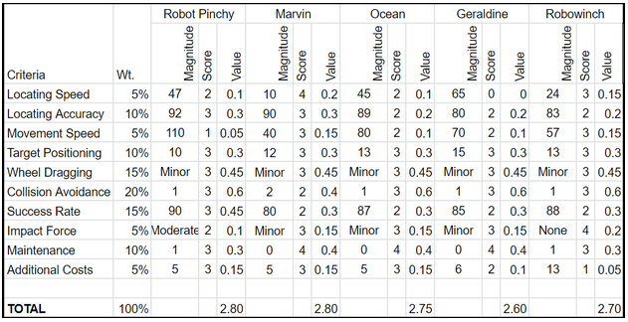

The scoring sheet is provided in Appendix A.

## 3.2 References

[1] D. Riddell, “RFP-VN120-202001 PROTOTYPE DESIGNS FOR AN AUTONOMOUS UNDERWATER SENSOR-CLEANING ROBOT,” unpublished.

[2] VEX Robotics. “VEX V5.” vexrobotics.com. https://www.vexrobotics.com/vexedr

Appendix A - Weighted Objective Chart Scoring Sheet

Table 2: Weighted Objectives Chart Scoring Sheet

